STARTECT Dual Active Oral Solution for Sheep

PRESENTATION
STARTECT Dual Active Oral Solution for Sheep is a clear to hazy, colourless to yellow-brown solution containing 10 mg/ml derquantel and 1 mg/ml abamectin. Also contains 0.5 mg/ml butylated hydroxytoluene as excipient.

USES
STARTECT Dual Active is a broad spectrum anthelmintic for the treatment and control of mixed gastro-intestinal nematode infections and associated diseases of sheep.
STARTECT Dual Active is effective against strains of parasites resistant to benzimidazoles, levamisole, macrocyclic lactones, and combinations of these.
The spectrum of activity is as follows:
Adult and Immature Gastro-intestinal Nematodes:
Haemonchus contortus (including inhibited larval stages)
Teladorsagia (Ostertagia) circumcincta (including inhibited larval stages)
Teladorsagia (Ostertagia) trifurcata
Trichostrongylus axei
Trichostrongylus colubriformis
Trichostrongylus vitrinus
Cooperia curticei
Cooperia oncophora
Nematodirus spathiger
Nematodirus filicollis
Nematodirus battus
Strongyloides papillosus
Oesophagostomum venulosum (adult)
Trichuris ovis
Chabertia ovina
Lungworms:
Dictyocaulus filaria (adult)

DOSAGE AND ADMINISTRATION
STARTECT Dual Active is a ready-to-use oral solution.
The dose for sheep is 2 mg derquantel and 0.2 mg abamectin per kg bodyweight, i.e. 1 ml of product per 5 kg bodyweight.
Drench sheep orally, using a drench gun with silicone sealed ‘o’ rings.
Check dose rates and the accuracy of the drench gun before treatment commences.
Do not under- or over-dose. To ensure administration of a correct dose, bodyweight should be determined as accurately as possible. If animals are to be treated collectively rather than individually, they should be grouped according to their bodyweight and dosed accordingly.

Figure 1: | Figure 2:
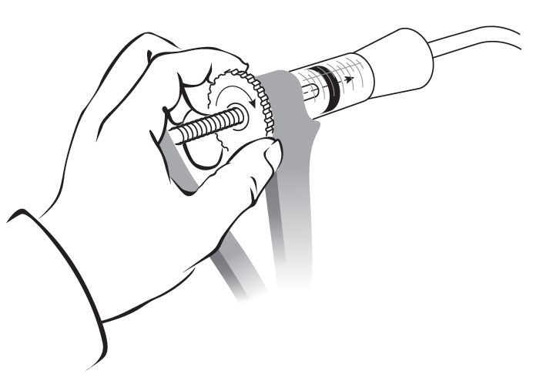 | 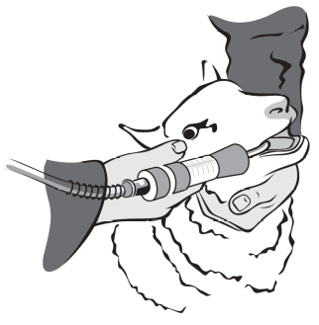
Set the dosing gun to deliver the correct dose volume for the weight of sheep to be treated. | Gently place the nozzle of the drench gun over the back of the tongue and depress the trigger.

CONTRA-INDICATIONS, WARNINGS, ETC
Do not use in dogs as severe adverse reactions may occur.
Do not use in horses as severe adverse reactions, including fatalities, will occur.
Do not exceed the recommended dose rate.
Care should be taken to avoid the following practices because they increase the risk of development of resistance and could ultimately result in ineffective therapy:
• Underdosing, which may be due to underestimation of bodyweight, misadministration of the product or lack of calibration of the dosing device.
• Too frequent and repeated use of anthelmintics from the same class over an extended period of time.
Assess bodyweight as accurately as possible before calculating dosage. Suspected clinical cases of resistance should be further investigated using the appropriate tests, e.g. (Faecal Egg Count Reduction Test). Where the results of the test(s) strongly suggest resistance to a particular anthelmintic, an anthelmintic belonging to another pharmacological class and having a different mode of action should be used.
The recommended dose of STARTECT Dual Active is 0.2 ml/kg; doses of 0.9 ml/kg and higher (4.5X the recommended dose) can cause signs of toxicity and may lead to fatalities.
If animals are batched for dosing it is very important that careful consideration be given to the weight range within each group, to avoid the risk of overdosing smaller animals. A representative sample of animals should be weighed before treatment.
Accuracy and proper functioning of the dosage device should be checked.
The safety of STARTECT Dual Active has not been established in sheep under six weeks of age or weighing less than 10 kg.
Mild transient coughing is very commonly reported following drenching.
Doses of 0.9 ml/kg and higher have been associated with symptoms of toxicity. Signs of toxicity include dullness, depression, incoordination, weakness, decreased gastrointestinal motility and abnormal breathing pattern, recumbency and death. Non-fatal adverse events have been shown to be fully reversible. Supportive veterinary care is indicated; there is no known antidote.
User warnings:
Do not eat, smoke or drink while handling the product.
Wear impermeable rubber gloves during use.
Avoid ingestion, inhalation and eye and skin contact. Wash hands after handling the product. In case of accidental ingestion, seek medical advice immediately. Show package leaflet or label to the physician.
In case of accidental eye or skin contact, wash affected areas immediately with clean running water and seek medical attention if irritation persists.
Withdrawal periods:
Meat and offal: 14 days.
Milk: do not use in lactating ewes producing milk for human consumption.

PHARMACEUTICAL PRECAUTIONS

Do not refrigerate or freeze.
Shelf-life after first opening the immediate packaging: 12 months.
Not to be mixed with other veterinary medicinal products before administration.
Any unused veterinary medicinal product or waste materials derived from such veterinary medicinal products should be disposed of in accordance with local requirements.
Extremely dangerous to fish and aquatic life. Do not contaminate water courses with the product or used container.
Keep out of the reach and sight of children.
For animal treatment only.

LEGAL CATEGORY
POM-V

PACKAGING QUANTITIES
Supplied in 1, 5 and 15 litre multi-dose packs. Not all pack sizes may be marketed.

FURTHER INFORMATION
Derquantel is the first member of the spiroindoles, a novel class of anthelmintics with a different mode of action from existing anthelmintic classes. Derquantel is a member of the 5-SI anthelmintic class.
Abamectin is a member of the macrocyclic lactone family (3-ML).
STARTECT can be used in pregnant, lactating and breeding animals.
STARTECT is toxic to dung insects. It is excreted mainly in the faeces and it cannot be excluded that insects using dung excreted after treatment may be adversely affected. Using the product strictly in accordance with the dosage instructions above will keep this risk to a minimum.

MARKETING AUTHORISATION NUMBER
Vm 42058/4135

